Vertical Combine ID-OD spray coating machine with indexing

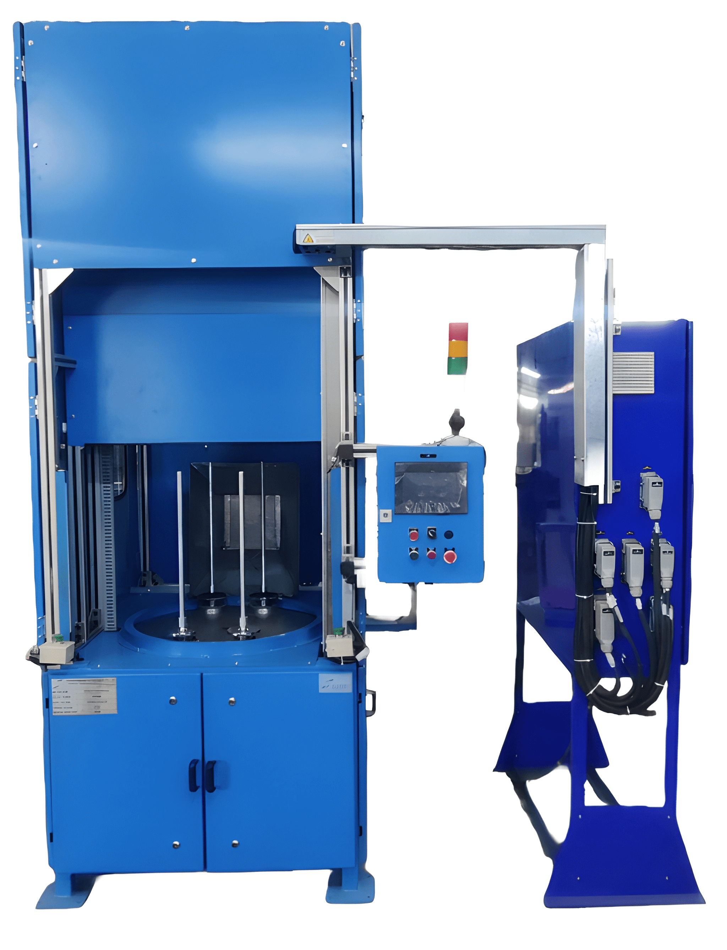

- Product Parameters:

Product | Vertical Combine ID-OD spray coating machine with indexing
Gun movement for ID (height) | Up to 400 mm
Gun movement for OD (height) | Up to 400 mm
Electrical Power Supply | 415 VAC, 50 Hz, 3 Phase
Pneumatic Air Supply | 4-6 bar
Auto Spray Guns | Lumina Gun
No. of Spindel’s | 4
Fluid Handling System | MS Pressure feed tank 20 lit/ 40 lit with stirrer motor and weighing scale
Auto flush | 2 lit Gun Cleaning Tank
Cycle Time | 3 sec
Cubic Feet per Minute (CFM) | 11
Loading/ Unloading | Manual Operation

